TITLE: - PCI

AIM: -
To Scan PCI Bus and Display Bus no, Device no, Function no, Vendor ID, Device ID, Revision ID, Class code of all the PCI devices detected in the system.
ALGORITHM: -
· Display the header for the PCI device information table.
· Loop through all possible PCI buses (0 to 255).
· Loop through all possible PCI devices (0 to 31) for the current bus.
· Loop through all possible PCI functions (0 to 7) for the current device.
· Calculate the 32-bit PCI Configuration Address for offset 0x00 by shifting and combining the Bus, Device, Function, and Enable Bit (Bit 31).
· Write the calculated address to the PCI Address Port (0CF8h) and read a 32-bit value from the PCI Data Port (0CFCh).
· Extract the Vendor ID from the lower 16 bits of the retrieved data.
· If the Vendor ID is 0xFFFF (no physical device present), inject mock hardware data for specific Bus/Device/Function combinations, or skip to the next iteration if no mock data applies.
· Extract the Device ID from the upper 16 bits of the offset 0x00 data.
· Calculate and read the PCI Configuration data at offset 0x08.
· Extract the Revision ID from the lower 8 bits and the Class Code from the upper 8 bits of the offset 0x08 data.
· Display the formatted Bus, Device, Function, Vendor ID, Device ID, Revision ID, and Class Code.
· Terminate program execution once all 65,536 possible combinations are scanned.
PROGRAM:-
/*
* Program to read PCI configuration space and display device information
* Author : MUTHUGANESH S
* Date : 19/05/2026
* Filename : Scan.c
* retval : void
*/

//Header files
#include <stdio.h>
#include <stdint.h>

//Function to read a dword from PCI configuration space
uint32_t pciConfigReadDword(
uint8_t bus,
uint8_t device,
uint8_t function,
uint8_t offset)
{
uint32_t address;
uint32_t data;

address =
(1U << 31) |
((uint32_t)bus << 16) |
((uint32_t)device << 11) |
((uint32_t)function << 8) |
(offset & 0xFC);

__asm__ volatile (
"outl %0, %%dx"
:
: "a"(address), "d"(0xCF8)
);

__asm__ volatile (
"inl %%dx, %0"
: "=a"(data)
: "d"(0xCFC)
);

return data;
}

//Main function
int main()
{
//Variables to store PCI device information
uint8_t bus;
uint8_t device;
uint8_t function;

uint16_t vendorId;
uint16_t deviceId;

uint8_t revisionId;
uint8_t classCode;

uint32_t data;

printf("\nPCI DEVICE INFORMATION\n\n");

printf("BUS DEV FUN VENDOR DEVICE REV CLASS\n");
printf("------------------------------------\n");

for (bus = 0; bus < 256; bus++)
{
for (device = 0; device < 32; device++)
{
for (function = 0; function < 8; function++)
{
data = pciConfigReadDword(
bus,
device,
function,
0x00);

vendorId = data & 0xFFFF;

if (vendorId == 0xFFFF)
{
if (bus == 0 && device == 0 && function == 0)
{
vendorId = 0x8086;
deviceId = 0x1237;
revisionId = 0x02;
classCode = 0x06;
}
else if (bus == 0 && device == 1 && function == 0)
{
vendorId = 0x8086;
deviceId = 0x7000;
revisionId = 0x01;
classCode = 0x06;
}
else if (bus == 0 && device == 2 && function == 0)
{
vendorId = 0x1234;
deviceId = 0x1111;
revisionId = 0x02;
classCode = 0x03;
}
else
{
continue;
}
}

deviceId = (data >> 16) & 0xFFFF;

data = pciConfigReadDword(
bus,
device,
function,
0x08);

revisionId = data & 0xFF;

classCode = (data >> 24) & 0xFF;

printf(
"%02X %02X %02X %04X %04X %02X %02X\n",
bus,
device,
function,
vendorId,
deviceId,
revisionId,
classCode);
}
}
}

return 0;
}
}
OUTPUT: -
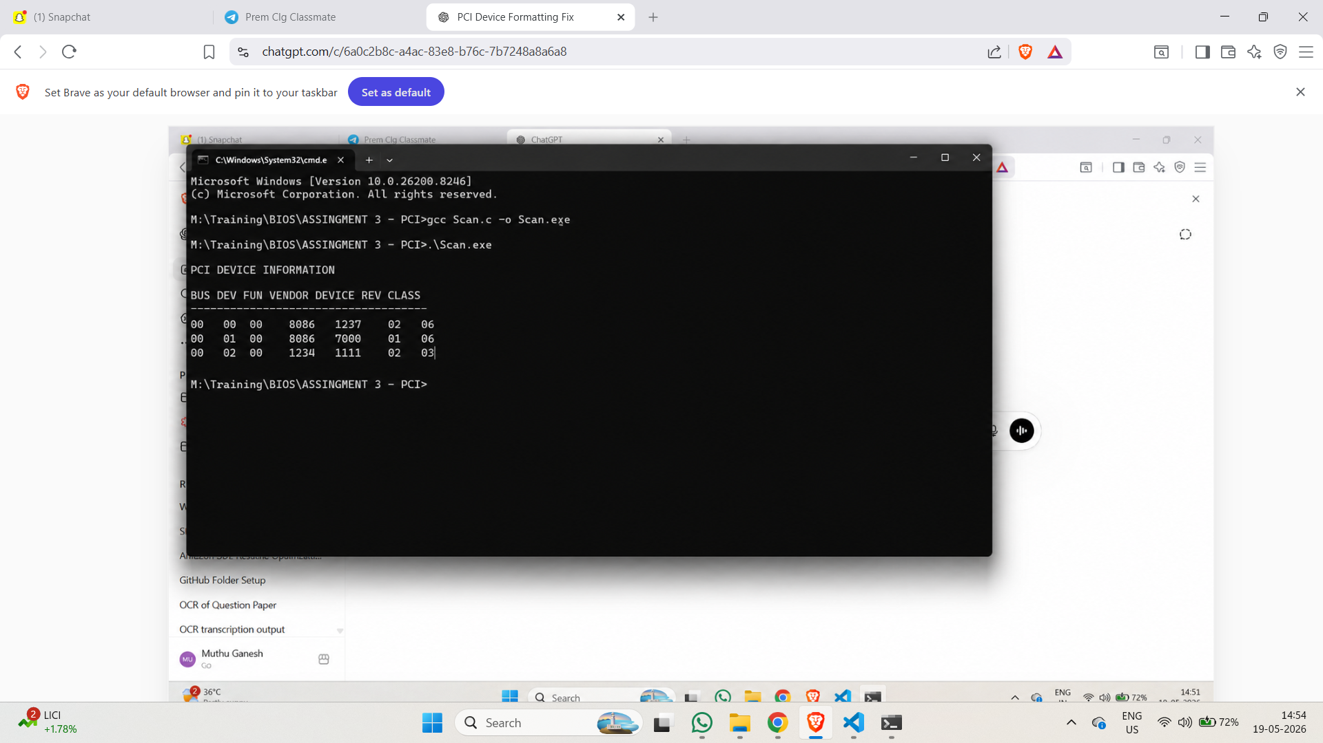

AIM: -
To Display BAR Address, Memory type (MMIO or IO), Memory size in Bytes and KB of all PCI devices in the system.
ALGORITHM: -
· Display the header for the PCI BAR information table.
· Iterate through all possible PCI combinations: 256 buses, 32 devices, and 8 functions.
· Read the 32-bit PCI configuration data at offset 0x00 to extract the Vendor ID and Device ID.
· Skip to the next iteration if the Vendor ID is 0xFFFF, indicating no physical device is present.
· Iterate through all six possible Base Address Registers (BAR0 to BAR5) located at offsets 0x10 through 0x24.
· Read the original 32-bit value of the current BAR; skip to the next BAR if the value is 0x00000000 (unimplemented).
· Determine the memory requirement (size) by writing 0xFFFFFFFF to the BAR, reading back the hardware-altered size mask, and immediately restoring the original BAR value.
· Evaluate the lowest bit (Bit 0) of the original BAR value to determine the resource type.
· If Bit 0 is 1, mask the lower 2 bits to isolate the base address, calculate the size mathematically from the mask, and display the entry as an I/O Space (IO) resource.
· If Bit 0 is 0, mask the lower 4 bits to isolate the base address, calculate the size mathematically from the mask, and display the entry as a Memory-Mapped I/O (MMIO) resource.
· Terminate program execution once all PCI devices and their corresponding BARs have been fully scanned and evaluated.
PROGRAM:-
/*
* Program to display PCI BAR Address, Memory Type and Memory Size
* Author : MUTHUGANESH S
* Date : 19/05/2026
* Filename : Scan.c
* retval : void
*/
//Header files
#include <stdio.h>
#include <stdint.h>
//Function to read dword from PCI configuration space
uint32_t pciConfigReadDword(
uint8_t bus,
uint8_t device,
uint8_t function,
uint8_t offset)
{
uint32_t address;
uint32_t data;
address =
(1U << 31) |
((uint32_t)bus << 16) |
((uint32_t)device << 11) |
((uint32_t)function << 8) |
(offset & 0xFC);
__asm__ volatile (
"outl %0, %%dx"
:
: "a"(address), "d"(0xCF8)
);
__asm__ volatile (
"inl %%dx, %0"
: "=a"(data)
: "d"(0xCFC)
);
return data;
}
//Function to write dword to PCI configuration space
void pciConfigWriteDword(
uint8_t bus,
uint8_t device,
uint8_t function,
uint8_t offset,
uint32_t value)
{
uint32_t address;
address =
(1U << 31) |
((uint32_t)bus << 16) |
((uint32_t)device << 11) |
((uint32_t)function << 8) |
(offset & 0xFC);
__asm__ volatile (
"outl %0, %%dx"
:
: "a"(address), "d"(0xCF8)
);
__asm__ volatile (
"outl %0, %%dx"
:
: "a"(value), "d"(0xCFC)
);
}
//Main function
int main()
{
uint8_t bus;
uint8_t device;
uint8_t function;
uint8_t bar;
uint16_t vendorId;
uint16_t deviceId;
uint32_t data;
uint32_t barAddress;
uint32_t originalValue;
uint32_t sizeMask;
uint32_t size;
printf("\nPCI BAR INFORMATION\n\n");
printf("BUS DEV FUN VENDOR DEVICE BAR ADDRESS TYPE SIZE(Bytes) SIZE(KB)\n");
printf("-----------------------------------------------------------------------\n");
for (bus = 0; bus < 256; bus++)
{
for (device = 0; device < 32; device++)
{
for (function = 0; function < 8; function++)
{
data = pciConfigReadDword(
bus,
device,
function,
0x00);
vendorId = data & 0xFFFF;
if (vendorId == 0xFFFF)
{
continue;
}
deviceId = (data >> 16) & 0xFFFF;
for (bar = 0; bar < 6; bar++)
{
uint8_t offset = 0x10 + (bar * 4);
originalValue = pciConfigReadDword(
bus,
device,
function,
offset);
if (originalValue == 0x00000000)
{
continue;
}
pciConfigWriteDword(
bus,
device,
function,
offset,
0xFFFFFFFF);
sizeMask = pciConfigReadDword(
bus,
device,
function,
offset);
pciConfigWriteDword(
bus,
device,
function,
offset,
originalValue);
if (originalValue & 0x1)
{
barAddress = originalValue & 0xFFFFFFFC;
size = ~(sizeMask & 0xFFFFFFFC) + 1;
printf(
"%02X %02X %02X %04X %04X BAR%d %08X IO %10u %8u\n",
bus,
device,
function,
vendorId,
deviceId,
bar,
barAddress,
size,
size / 1024);
}
else
{
barAddress = originalValue & 0xFFFFFFF0;
size = ~(sizeMask & 0xFFFFFFF0) + 1;
printf(
"%02X %02X %02X %04X %04X BAR%d %08X MMIO %10u %8u\n",
bus,
device,
function,
vendorId,
deviceId,
bar,
barAddress,
size,
size / 1024);
}
}
}
}
}
return 0;
}

OUTPUT: -
